# CodeCommit: The Key to Seamless and Secure Collaboration



**Phase 1-**

What if I tell you, in next some slides, you’ll be making a CI/CD pipeline on AWS with these tools.

* **CodeCommit**
* **CodeBuild**
* **CodeDeploy**
* **CodePipeline**
* **S3**

So Show me your interest in comment section and let’s start todays task.

# What is CodeCommit ?

AWS CodeCommit is a fully managed source control service that allows you to store and manage your code securely in the cloud. It provides a private Git repository for your code and supports all Git commands and workflows.

For example, if you have a team of developers working on a project, they can use CodeCommit to collaborate and manage their code changes. Each developer can clone the repository to their local machine, make changes, and then push those changes back up to the central repository in CodeCommit.

CodeCommit also integrates with other AWS services like AWS CodePipeline and AWS CodeBuild, allowing you to automate your entire software release process. This can help you streamline your development workflows and improve the overall efficiency of your team.

# Here is our Today’s Task-01 :

## - Set up a code repository on CodeCommit and clone it on your local.

* Login and Open the AWS Management Console and navigate to the CodeCommit service.

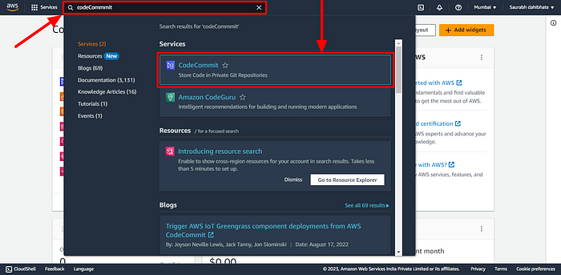

* Create a new repository by clicking on the “Create repository” button.

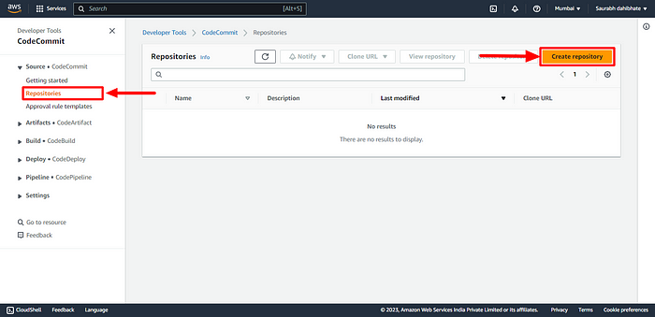

* Enter a name for your repository and select the options for repository description, default branch name, and repository visibility.

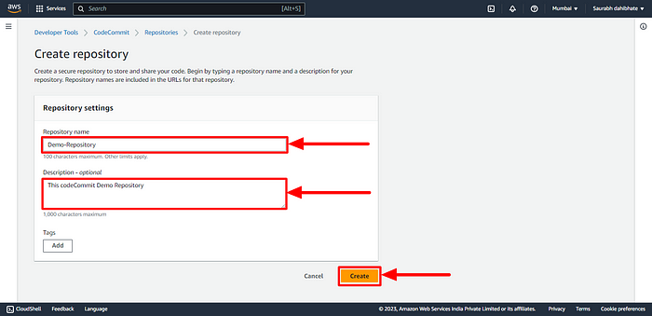

* Demo-Repository Successfully Created.

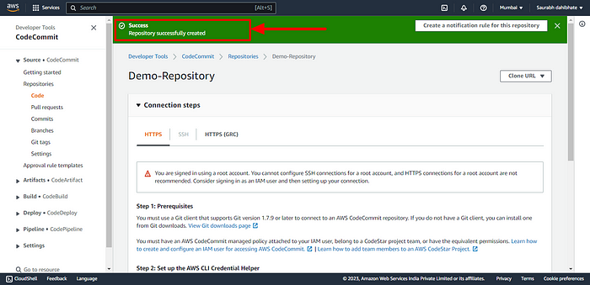

**You need to setup Git Credentials in your AWS IAM.**

* Go to IAM console
* Click on Users in the left-hand menu, and then click on your username.

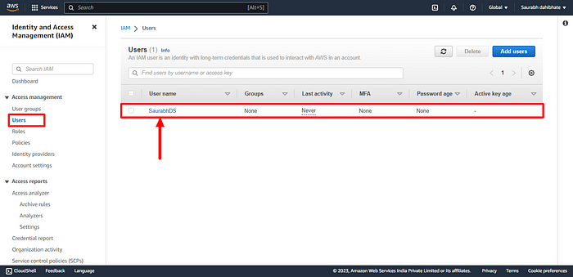

* Add permission for git access for IAM user

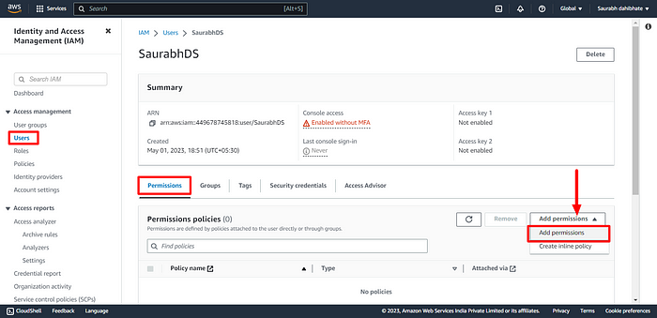

* Search and select “AWSCodeCommitFullAccess” “AWSCodeCommitPowerUser”.

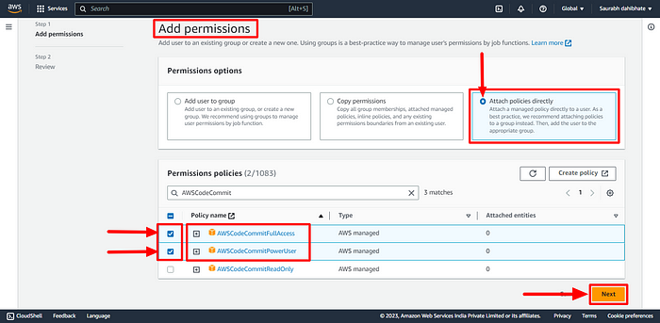

* Click Add Button and add the policies to the user.

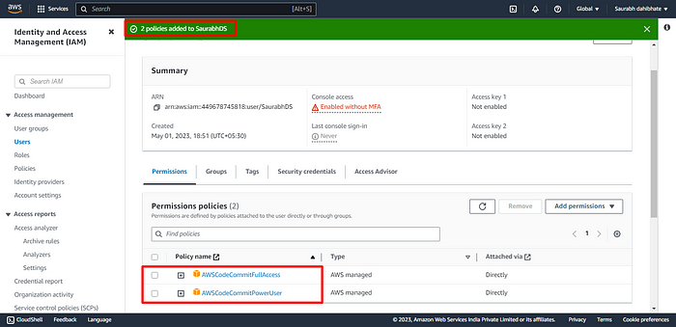

* Scroll down to the Security credentials section.

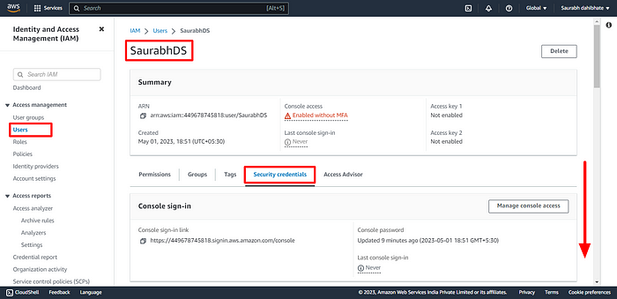

* In “HTTPS Git credentials for AWS CodeCommit” section, click on “Generate credentials”.

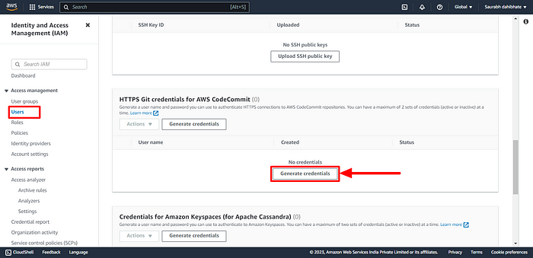

* Click on the Download credentials button to download your Git credentials and click on “close”.

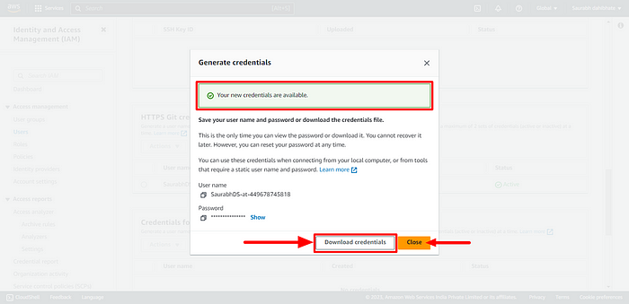

* Git credentials is created.

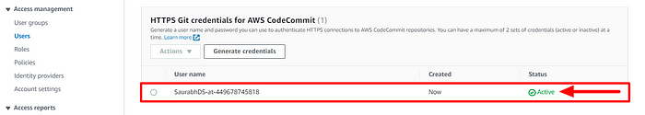

**Use those credentials in your local and then clone the repository from CodeCommit.**

* Navigate to the created repository and select add file option to create a file manually.

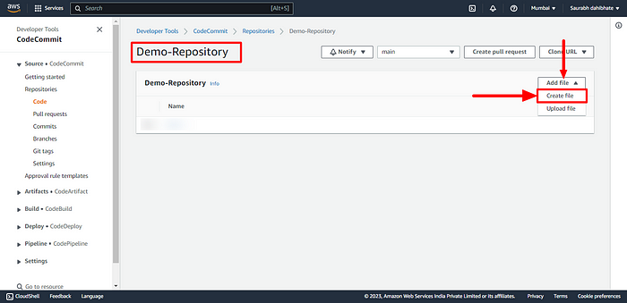

* Provide the content of the file along with the commit information.

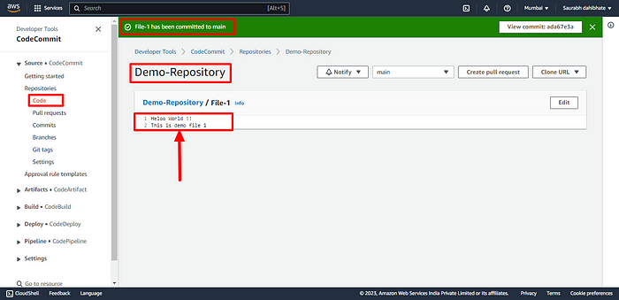

* You can now view the newly created file. Then copy the repository URL.

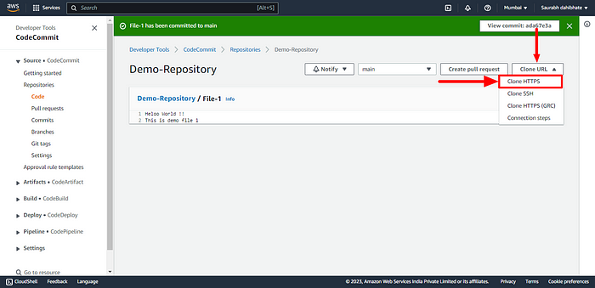

* Open the server terminal and use the git clone command to clone the repository from CodeCommit to the server.

git clone <your-codecommit-repo-clone-https-url>

* You will be prompted to enter your Git credentials. Enter the username and password that you downloaded earlier.

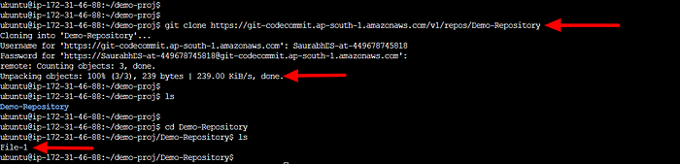

You have now set up a CodeCommit repository and cloned it on your local machine using Git Credentials in AWS IAM.

# Here is our Today’s Task-02 :

## - Add a new file from local and commit to your local branch.

* Create a new file in the local repository directory.

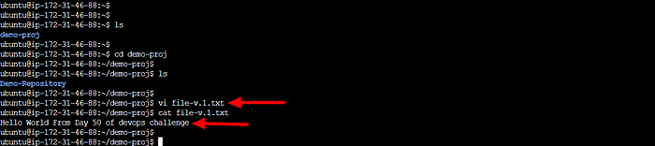

* Check status using command “git status”.

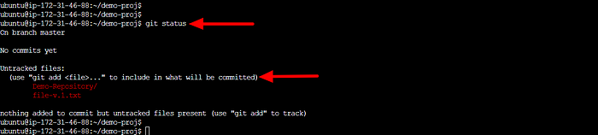

* Add the new file to your local branch using the following command:

git add <filename>

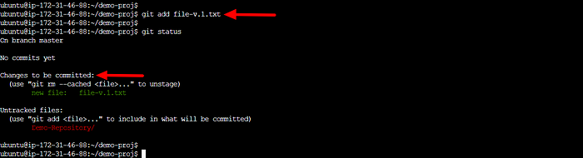

* Commit the changes to your local branch using the following command:

git commit -m "added new file"

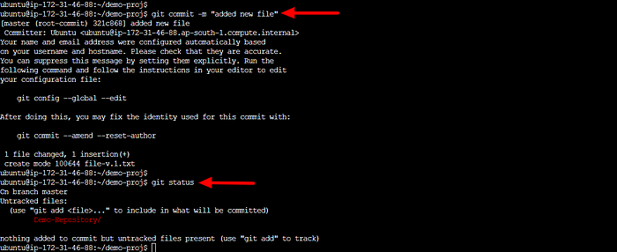

## - Push the local changes to CodeCommit repository.

Push the changes from your local branch to the CodeCommit repository using the following command:

git push origin master

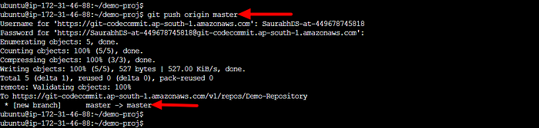

* Verify that the changes have been pushed to the CodeCommit repository:
* Go to the code commit repository that you created earlier, you should see the new file listed in the repository’s files.

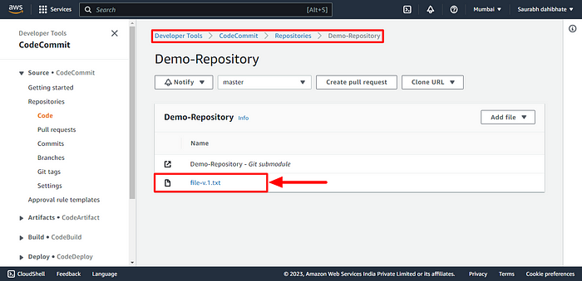

* You can see content of the file.

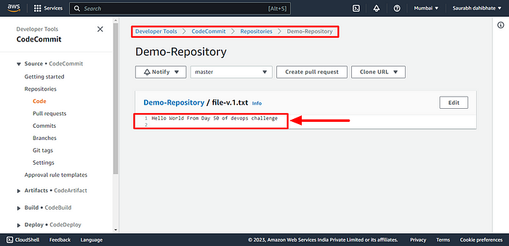

**Phase 2-**

# What is CodeBuild ?

AWS CodeBuild is a fully managed build service that compiles source code, runs tests, and produces software packages that are ready to deploy. With CodeBuild, you don’t need to worry about provisioning and managing your own build infrastructure. You simply provide your build project’s source code and build settings, and CodeBuild handles the rest.

For example, if you have a web application that you want to deploy, you can use CodeBuild to compile your source code, run unit tests, and produce a deployable package. You can also use CodeBuild to build Docker images, run static code analysis, and more. CodeBuild integrates with other AWS services like CodePipeline, so you can easily automate your entire software release process.

# Here is our Today’s Task-01 :

## - What is Buildspec file for Codebuild.

The Buildspec file is a configuration file used by AWS CodeBuild to define how to build and deploy your application or software project. It is written in YAML or JSON format and contains a series of build commands, environment variables, settings, and artifacts that CodeBuild will use during the build process.

## - Create a simple index.html file in CodeCommit Repository.

* Open the AWS Management Console and navigate to the CodeCommit service.
* Select the repository where you want to add the index.html file.

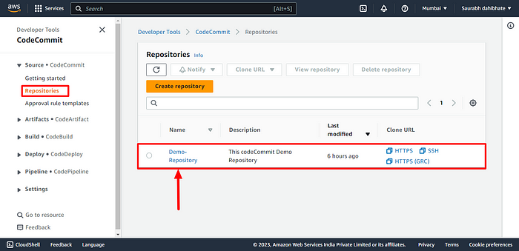

* Click on the “Create file” button.

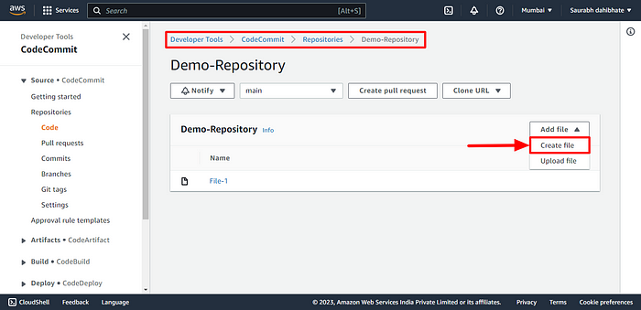

* Enter “index.html” as the file name and add the following content in the editor:

<html>  
 <head>  
 <title>My Website</title>  
 </head>  
 <body>  
 <h1>Welcome to my website</h1>  
 <p>This is a simple website hosted on AWS CodeCommit.</p>  
 </body>  
</html>

* Click on the “Commit file” button to save the changes.

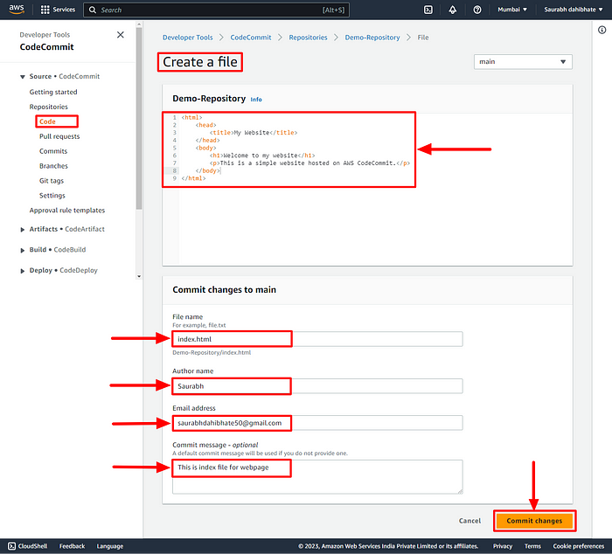

* Clone the repository to your instance and verify the files.

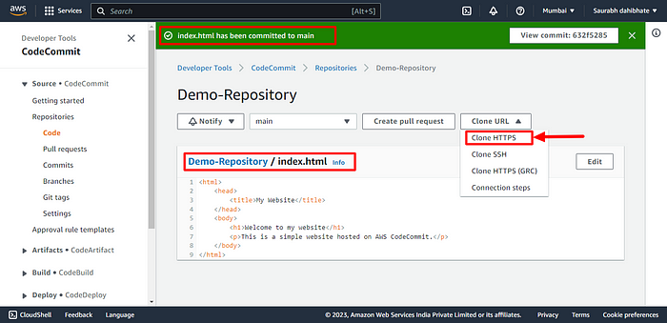

* Clone the repository to your instance and verify the files.

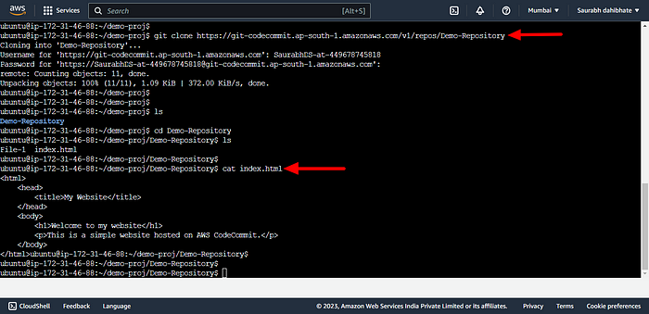

# Here is our Today’s Task-02 :

## ****- Add buildspec.yaml file to CodeCommit Repository and complete the build process.****

* Create a buildspec.yaml file that will contain the pre-build,during build,post-build, storage artifacts to be performed on the server during the project build.

version: 0.2  
  
phases:  
 install:  
 commands:  
 - echo Installing NGINX - echo apt-get install NGINX  
 - sudo apt-get update  
 - sudo apt-get install nginx -y  
 build:  
 commands:  
 - echo Build started on date`  
 - cp index.html /var/www/html  
 post_build:  
 commands:  
 - echo Configuring NGINX  
artifacts:  
 files:  
 -/var/www/html/index.html

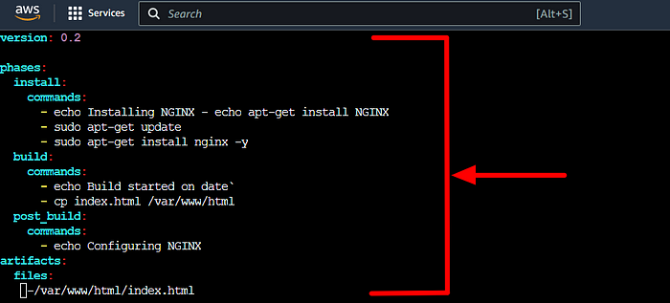

Below are the functions of each build step:

* The version of the **Buildspec** syntax we’re using is stated as version: **0.2.**
* **Phases:** This lists the stages of construction for our project.
* **install:** utilizes the apt-get package manager to install nginx on the built environment.
* **build** Places a copy of the index.html file in the nginx default web root directory.
* **post build:** If additional nginx settings are required, it is done.
* Indicates where the index.html file should be included in the **build artifact.**

With the git add and git commit commands, you can save the file and add the modifications to the repository.

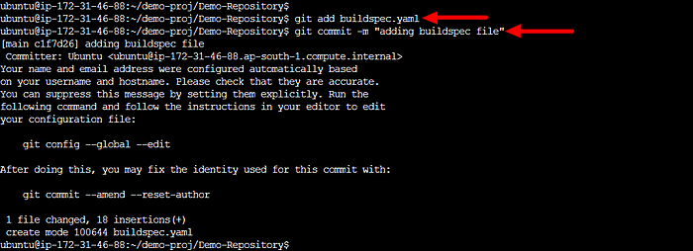

* Push the committed file to the remote repository of the CodeCommit repository.

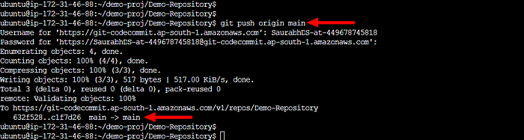

* Verify the file in remote repository along with the content.

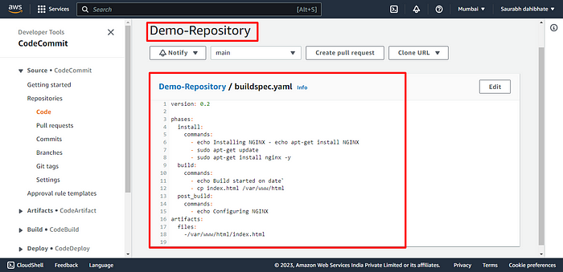

* Now, navigate to the CodeBuild section of AWS and build project.

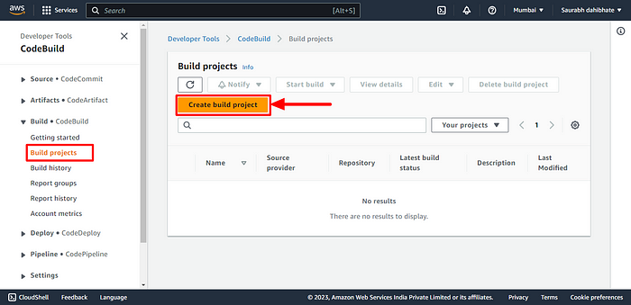

* Provide the appropriate details.

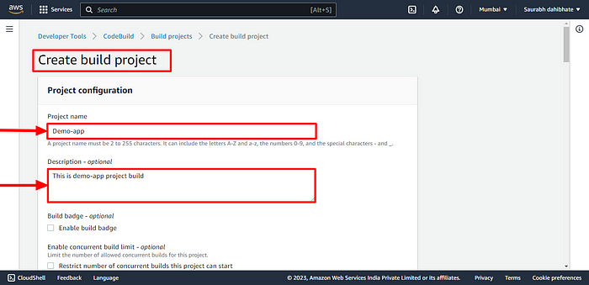

* Provide the repository details from which the project will pull the code.

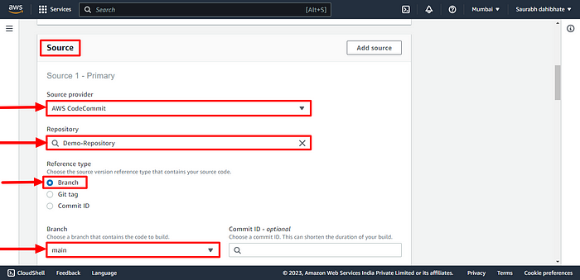

* Provide the environment details on which operating system the code needed to be run with the latest image.

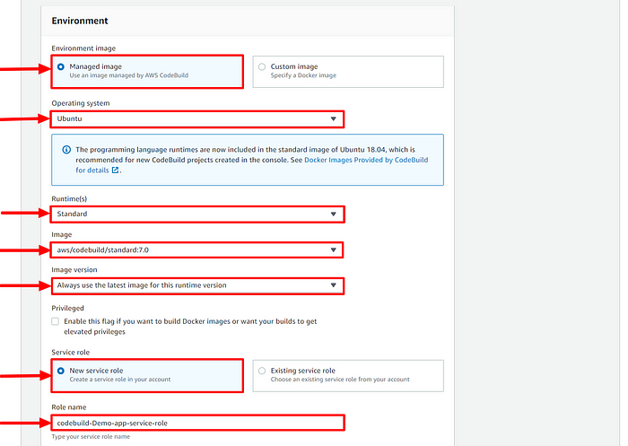

* Select Use build spec file in Buildspec section.
* Now Click on “Create build Project”.

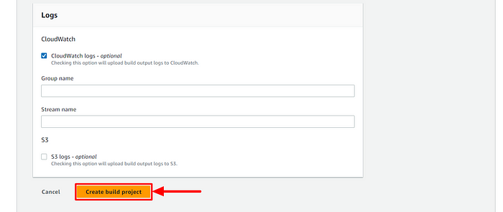

* Verify the project build details and now start the code build.

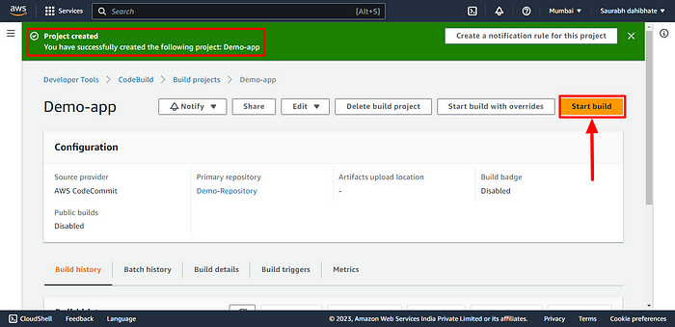

* Code build is completed and now verify the build phases.

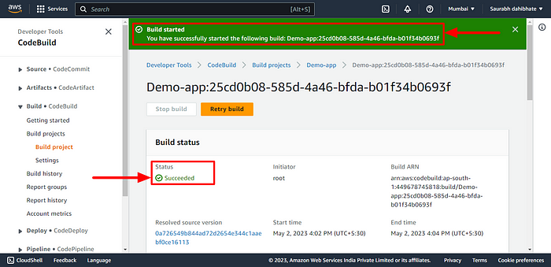

* All build phases are successfully completed.

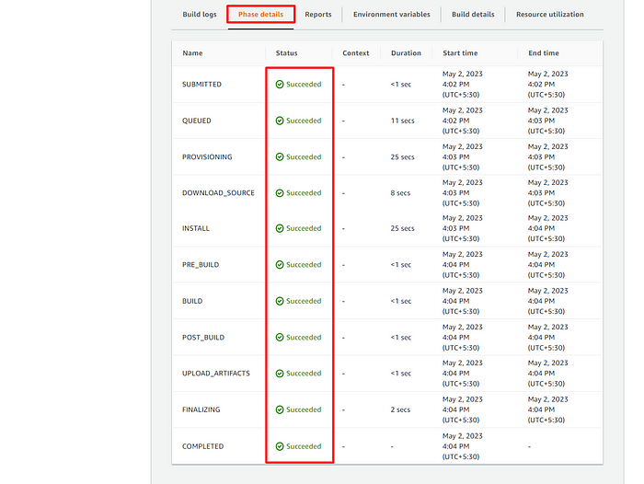

* You can store the build details in the artifactory with the successful build so that you can retrieve the same at any point in time.

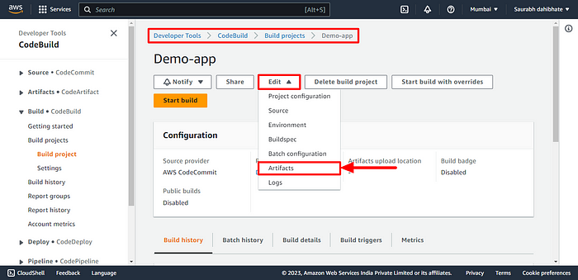

* Before that, create an S3 bucket. Navigate to the S3 bucket in the AWS console and provide the bucket name and create the bucket.

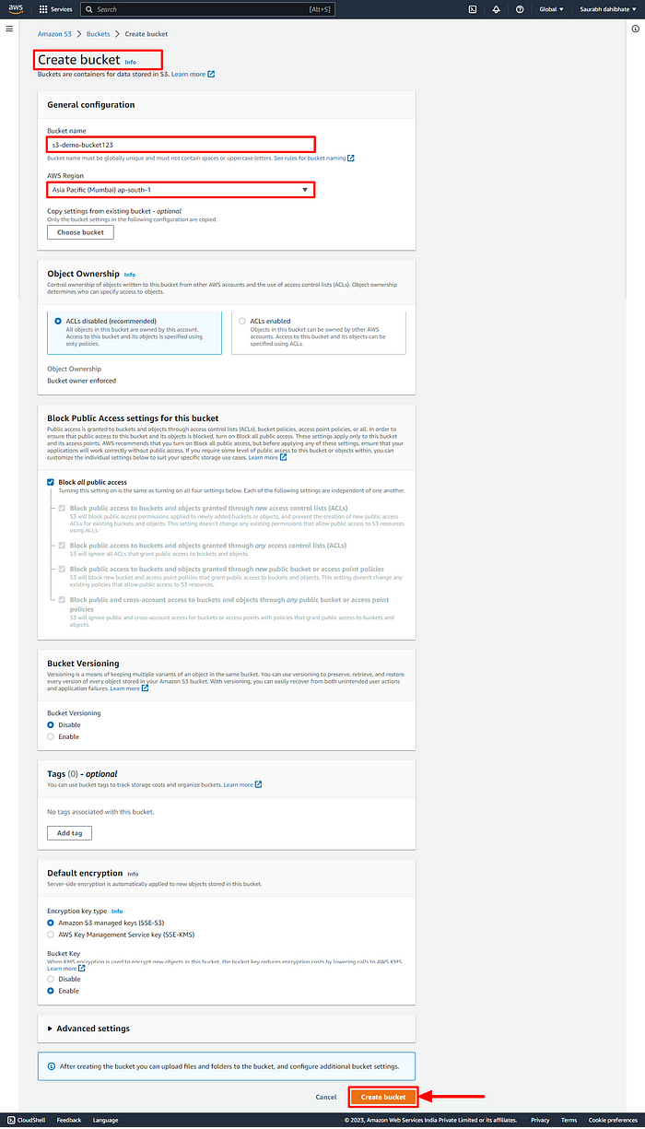

* Bucket is now created.

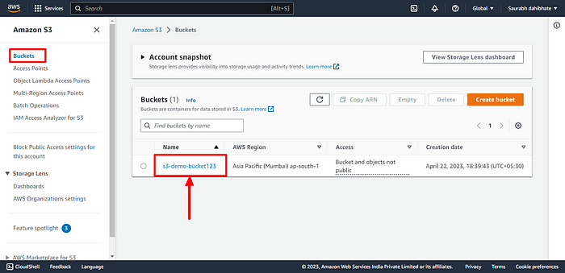

* Navigate to the project build, click on edit and select artefact. Provide all the details and create artifact.

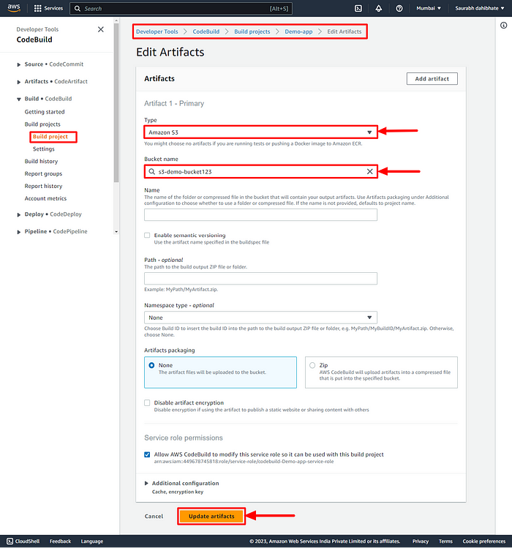

* Now, retry the build and you can see the UPLOAD_ARTIFACT section as succeeded.

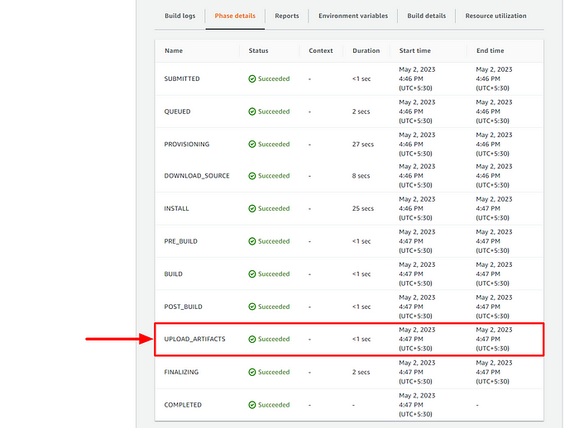

* Navigate to the S3 bucket and you can see the build.

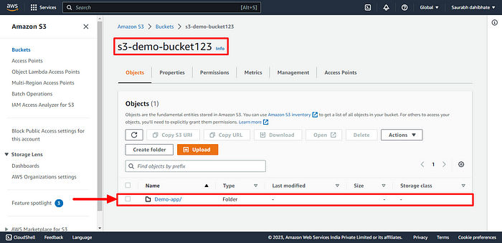

* Verify the build file and click open URL to open the demo-app

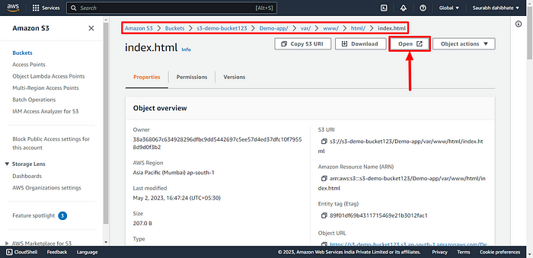

* Here is an output of index.html file.

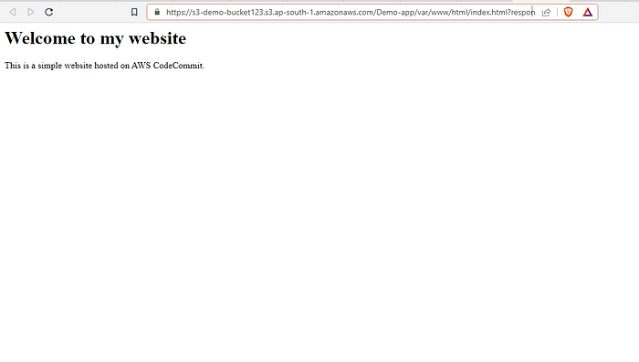

**Phase 3-**

**New day, New Topic…. Let’s learn along..!!**

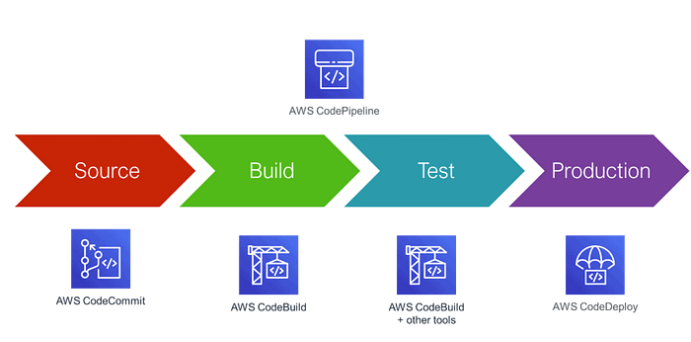

On our journey of making a CI/CD pipeline on AWS with these tools, you completed AWS CodeCommit & CodeBuild.

Next few days you’ll learn these tools/services:

* **CodeDeploy**
* **CodePipeline**
* **S3**

# What is CodeDeploy..?

AWS CodeDeploy is a service provided by Amazon Web Services (AWS) that helps you automate software deployment on various types of computing resources such as EC2 instances, on-premises servers, or Lambda functions.

In simple terms, it’s a tool that allows you to deploy your code to multiple servers at once, making it easier and faster to update your applications or websites. With AWS CodeDeploy, you can avoid the manual process of deploying code, reduce the risk of errors and downtime, and improve the overall efficiency of your deployment process.

# Here is our Today’s Task-01 :

## - What is Appspec.yaml file for CodeDeploy..??

The AppSpec file is a YAML-formatted file used by AWS CodeDeploy to manage the deployment of an application.

It provides instructions to CodeDeploy about the application’s source code, the deployment target, the scripts to run, and the permissions required to execute the scripts.

It also includes information about the deployment lifecycle hooks, which allow developers to execute custom scripts at specific points during the deployment process.

## - Deploy index.html file on EC2 machine using nginx..??

* Create an Instance or Restart previously created in AWS.

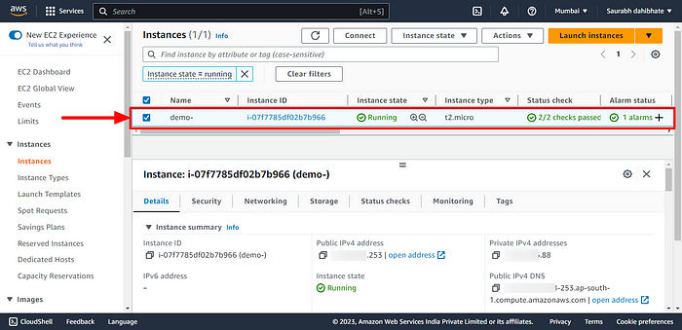

* Clone the CodeCommit repository to the server as we saw the same in my previous blog.
* The repository contained an HTML web application code. I have all files buildspec.yaml and index.html Task files.

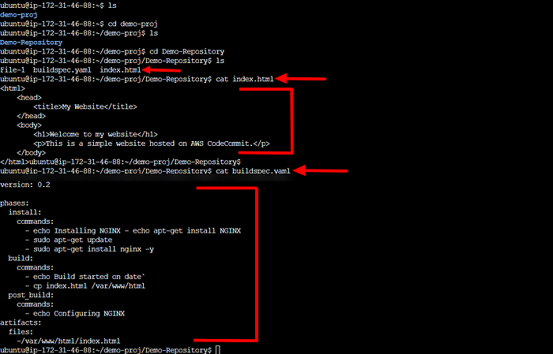

* We Build the code in the AWS CodeBuild section in the management section and the code commited, Build and stored in the S3 bucket.

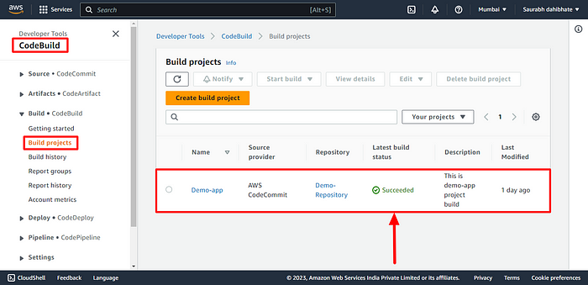

* For todays deployment we have to edit artifact configuration of project as follows.

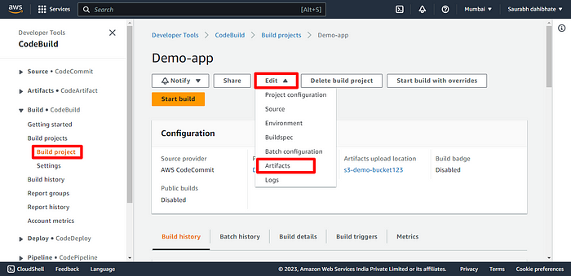

* Select Zip file format for code storage in S3.

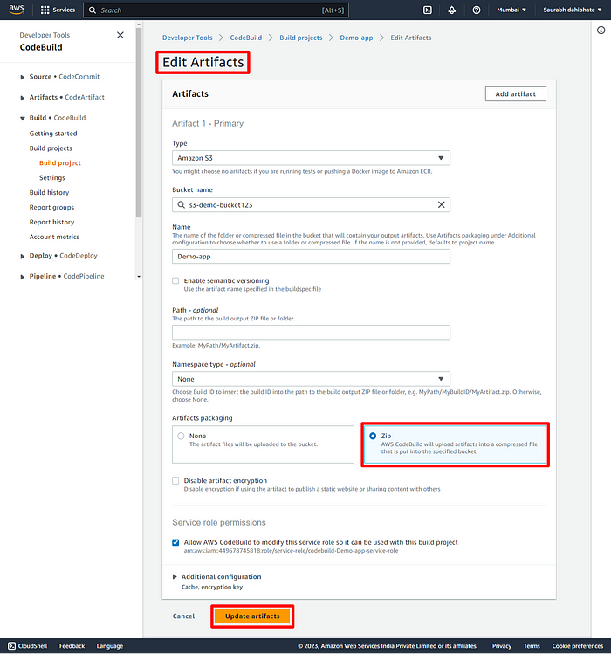

* Now, let’s navigate to the CodeDeploy section in AWS.

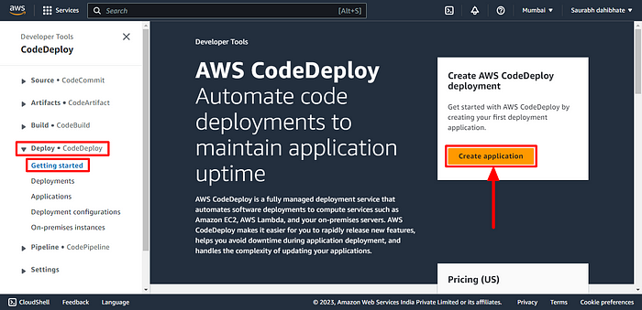

* Create an application by providing the name and compute platform. Here we are using EC2 instance.

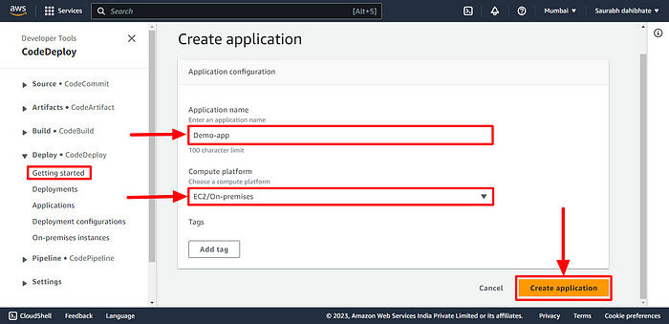

* The application is created now. Now create a deployment group.

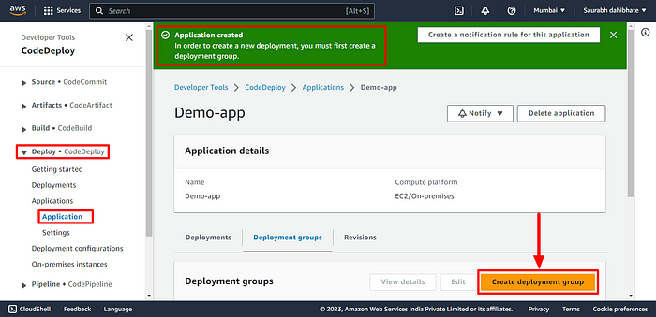

* Before that, we need to give access to deployment to access the AWS resource for which we need to create a role in IAM. Provide all the necessary access as mentioned below.

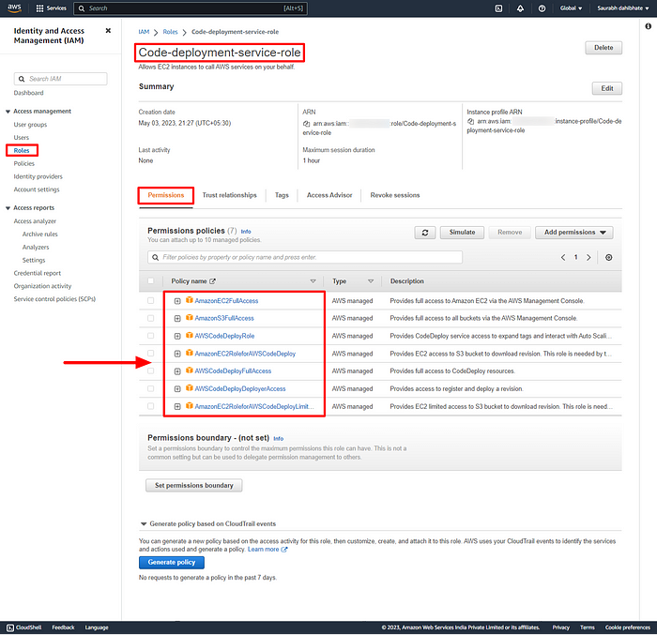

* Edit the trust policy and add Statement for CodeDeploy and update policy.

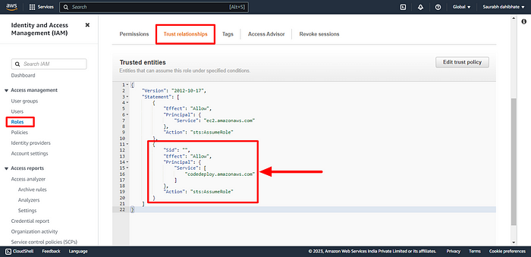

* Now, Create deployment group. Provide the deployment group name, and service role and enter the ARN id from the above role.

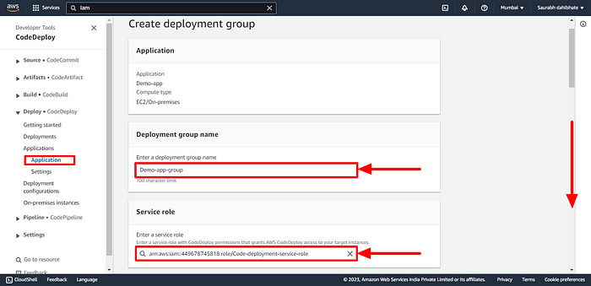

* Provide the EC2 instance details in Environment configuration.

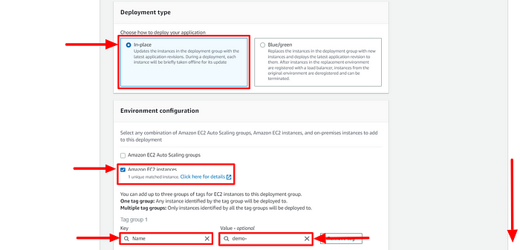

* Provide the below configurations. Now, Create deployment Group.

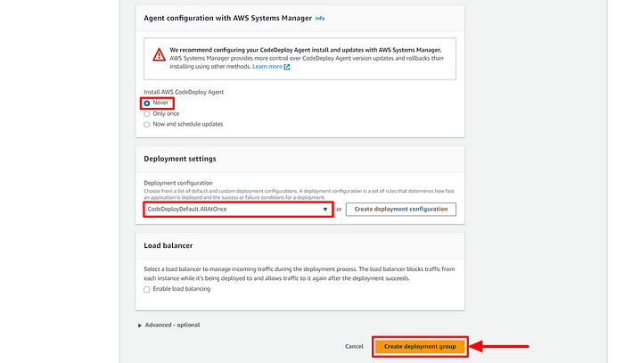

* A deployment group is now created.

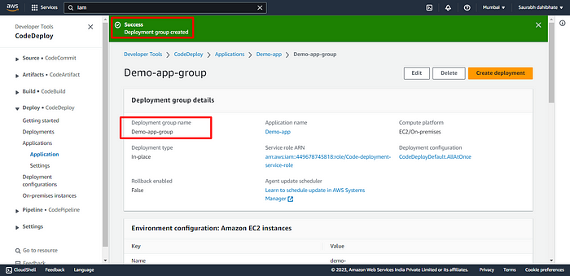

* We need to install the CodeDeploy agent on the server for which we need to write a script file with all the dependencies.

#!/bin/bash   
  
# This script installs the CodeDeploy agent and its prerequisites on Ubuntu 22.04.   
  
# Update package list  
sudo apt-get update   
  
# Install Ruby and its dependencies  
sudo apt-get install ruby-full ruby-webrick wget -y   
  
# Change to temporary directory  
cd /tmp   
  
# Download the CodeDeploy agent package  
wget https://aws-codedeploy-us-east-1.s3.us-east-1.amazonaws.com/releases/codedeploy-agent_1.3.2-1902_all.deb   
  
# Create a directory to extract the package contents  
mkdir codedeploy-agent_1.3.2-1902_ubuntu22   
  
# Extract the package contents  
dpkg-deb -R codedeploy-agent_1.3.2-1902_all.deb codedeploy-agent_1.3.2-1902_ubuntu22   
  
# Update the package dependencies to use Ruby 3.0  
sed 's/Depends:.*/Depends:ruby3.0/' -i ./codedeploy-agent_1.3.2-1902_ubuntu22/DEBIAN/control   
  
# Repackage the updated package  
dpkg-deb -b codedeploy-agent_1.3.2-1902_ubuntu22/   
  
# Install the updated package  
sudo dpkg -i codedeploy-agent_1.3.2-1902_ubuntu22.deb   
  
# List all systemd units that contain "codedeploy" in their name  
systemctl list-units --type=service | grep codedeploy   
  
# Check the status of the CodeDeploy agent service  
sudo service codedeploy-agent status

* Create install.sh file and execute the shell script.

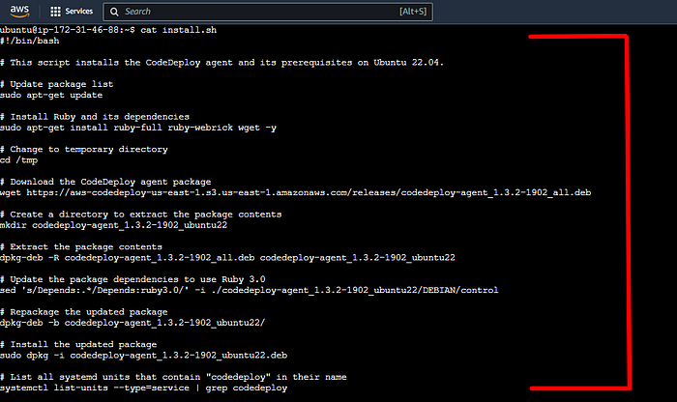

* Run the script file and all the dependencies are installed now on the server.
* CodeDeploy Agent is up and running.

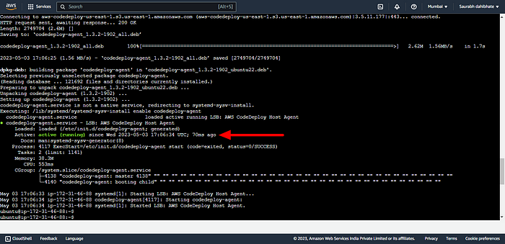

# Here is our Today’s Task-02 : Executing the code build and deployment

## ****- Add appspec.yaml file to CodeCommit Repository and complete the deployment process.****

* App Spec file is required to create a bridge between the AWS CodeDeploy and EC2 instance. Create the yaml file.
* appspec.yaml

version: 0.0 #specifies the version number of the file format.  
os: linux #specifies the operating system to be used.  
files: #is an array of files to be copied from the source to the destination directory.  
 - source:/ #specifies the source directory.  
destination: /var/www/html #specifies the destination directory where the files will be copied to.  
 hooks: #is an array of scripts to be executed at different points during the deployment process.  
 AfterInstall: #specifies a script to be executed after the installation of the application.  
 - location: scripts/install_nginx.sh #specifies the location of the script file to be executed  
 timeout: 300 #specifies the maximum amount of time in seconds that the script can run for.  
 runas: root #specifies the user that the script should be run as.  
 ApplicationStart: #specifies a script to be executed after the application has started.  
 - location: scripts/start_nginx.sh  
 timeout: 300  
 runas: root

* Create the dependency files as well for installing and starting nginx on the server.
* install_nginx.sh

#!/bin/bash  
  
sudo apt-get update && sudo apt-get install -y nginx

* start_nginx.sh

#!/bin/bash  
  
sudo systemctl start nginx  
sudo systemctl enable nginx

* Make sure to change the buildspec.yaml file so that the CodeBuild will build the appspec.yml file and transfer the artifact to S3 bucket.

version: 0.2  
  
phases:  
 install:  
 commands:  
 - echo Installing NGINX - echo apt-get install NGINX  
 - sudo apt-get update  
 - sudo apt-get install nginx -y  
 build:  
 commands:  
 - echo Build started on date  
 - cp index.html /var/www/html  
 post_build:  
 commands:  
 - echo Configuring NGINX  
artifacts:  
 files:  
 - "**/*"

Here is all required files index.html, buildspec.yaml, appspec.yaml, install_nginx.shand start_nginx.sh.

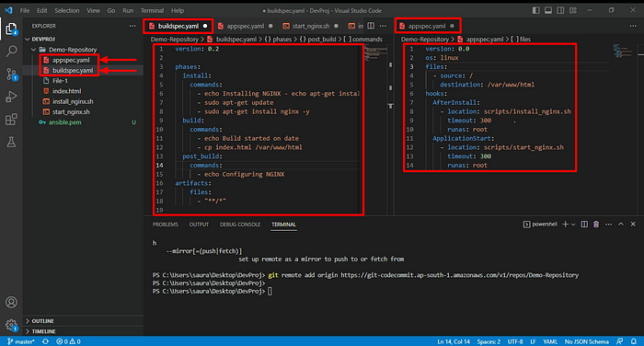

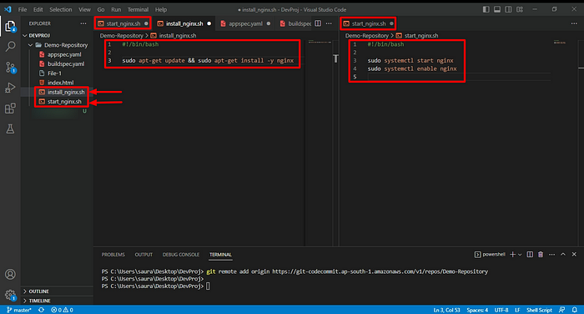

* Commit the code and transfer all to the CodeCommit repository.

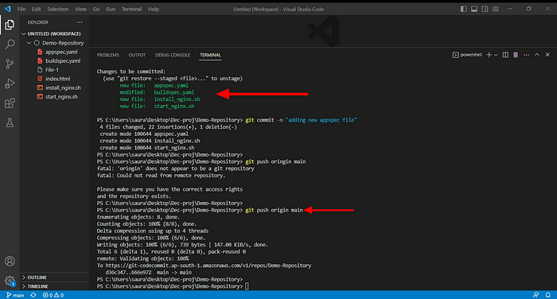

* You can view the new code files in the CodeCommit repository.

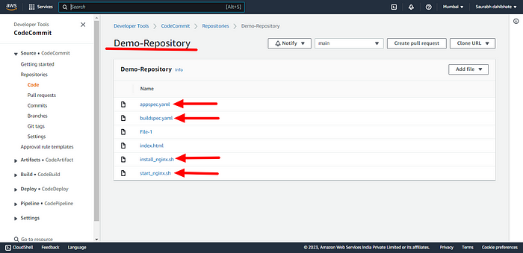

* Build the project now.

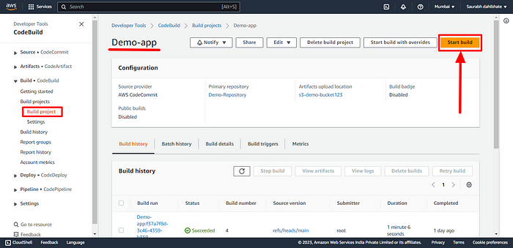

* Project successfully build

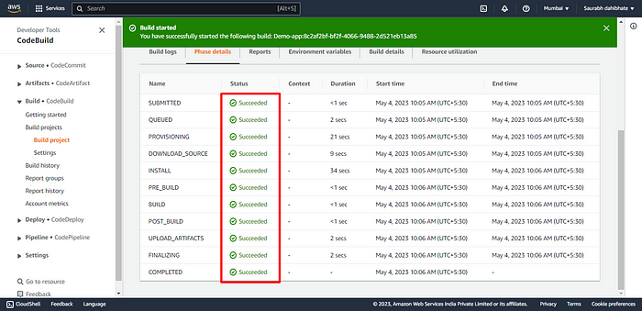

* Now create a deployment in the deployment group that we made previously.
* But before that we have to Create a role for giving access to EC2 instance with all the neccessary permission policies as shown below.

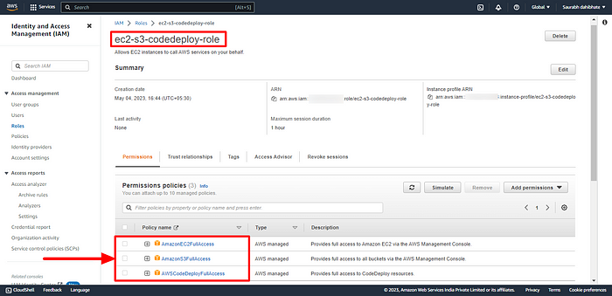

* Now, navigate to the instance and modify the IAM role. Select the IAM role created above.

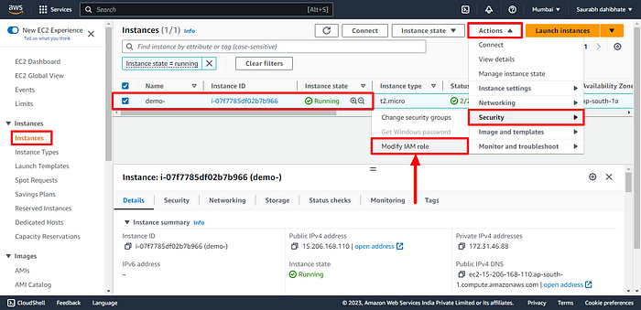

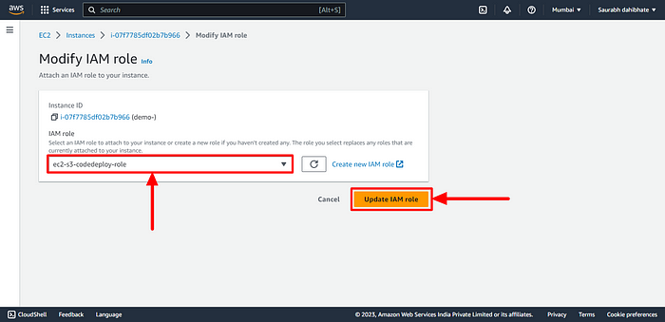

* Now create a deployment in the deployment group that we made previously.

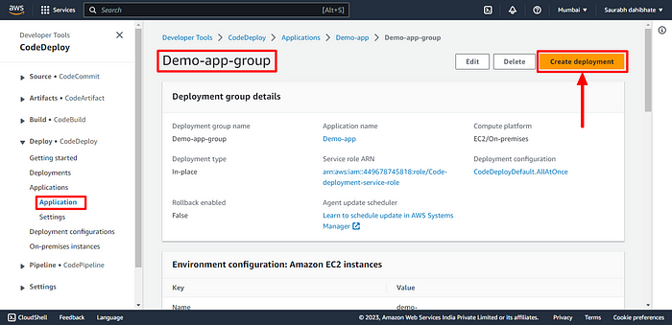

* Provide the S3 artifactory details. This will pull the code at the time of CodeDeploy. Then create the deployment.

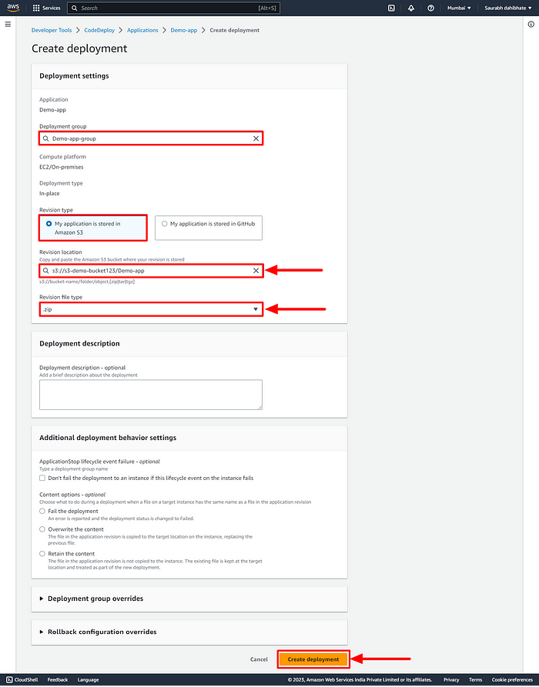

* Execute the deployment. But we can see the code is not getting deployed.
* Restart the codedeploy-agent in the EC2 instance.

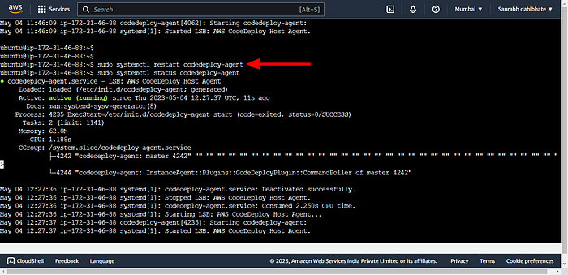

* HHuuusssh Finally, the Code deploy is successful.

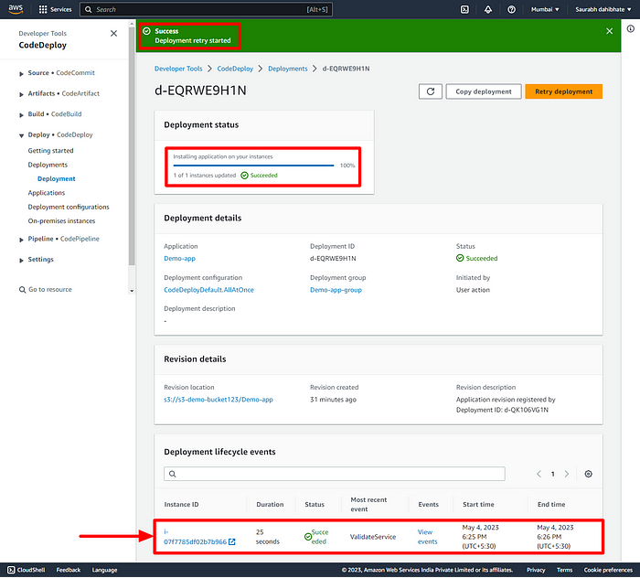

* Verify the Public IP of the instance to view the Webpage.

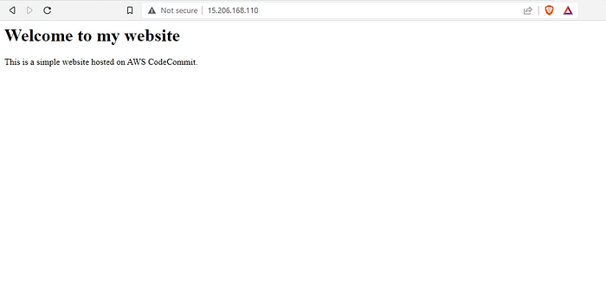

**Phase 4-**

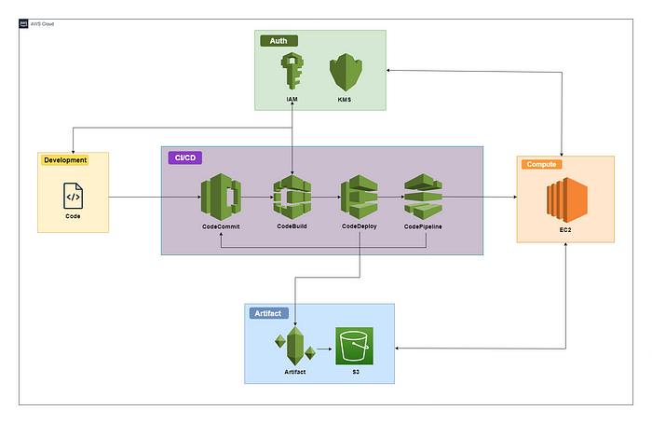

On our journey of making a CI/CD pipeline on AWS with these tools, you completed AWS CodeCommit, CodeBuild & CodeDeploy in previous phases.

Finish Off in style with AWS CodePipeline

# What is CodePipeline..??

AWS CodePipeline is a continuous delivery service provided by Amazon Web Services (AWS) that helps you automate the software release process for your applications.

With AWS CodePipeline, you can model, visualize, and automate the different stages of your software delivery process, from building and testing to deploying and monitoring.

It enables you to rapidly and reliably deliver features and updates to your customers, while reducing the risk of errors and downtime.

# Here is our Today’s Task-01 :

## - Create a CodePipeline that gets the code from CodeCommit, Builds the code using CodeBuild and deploys it to a Deployment Group.

* This is the last part-04 of CI/CD pipeline. Please refer part 1, 2, 3 of CI/CD for better understanding.
* I have explain the initial stages CodeCommit, CodeBuild, CodeDeploy of pipeline in previous parts.
* Let’s start today’s task navigate to the CodePipeline section in the AWS management console.

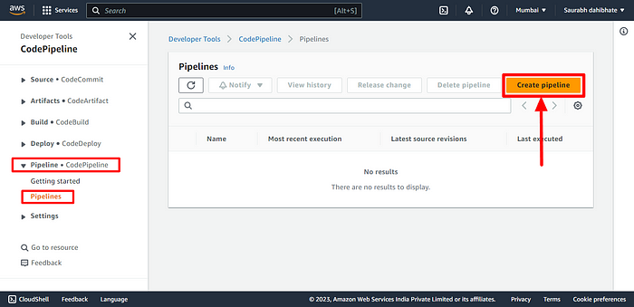

* Provide the Pipeline naming details and let the service role to be default.

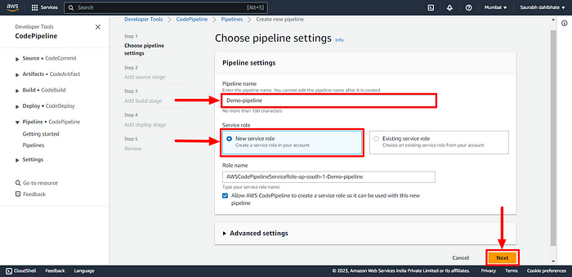

* Provide the Code repository details. In our case, we have our code in webapp folder in CodeCommit repository. Choose AWS CodePipeline to automatically execute the pipeline in case of any changes in the code automatically.

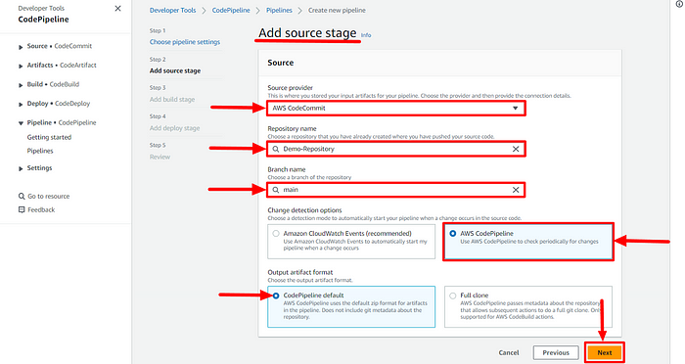

* Now add the Build stage details. Select the build provider and give the project name.

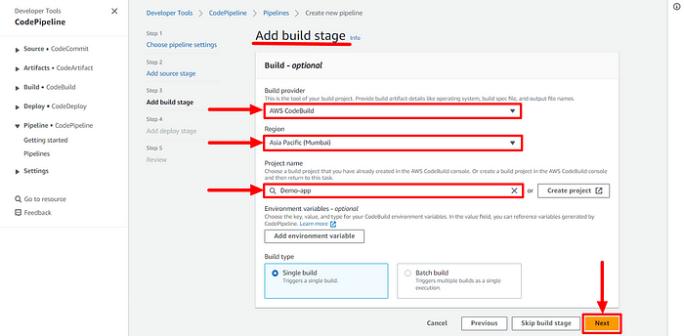

* Now add the deploy stage. Select the provider and name of the already created application and deployment group.

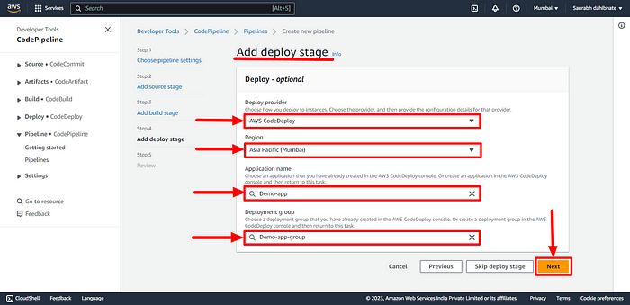

* Now verify the details and create the code pipeline.

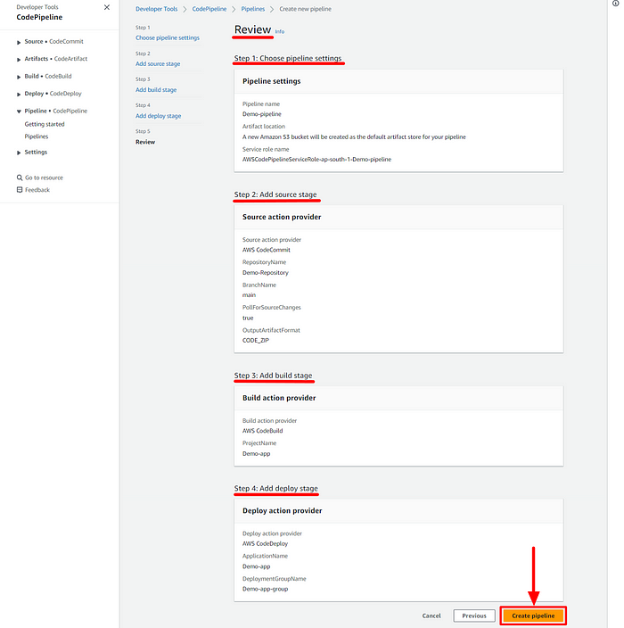

* The pipeline will now fetch the code from the CodeCommit repository.
* Then, it will build the code and deploy in the server as we can see in the below screenshot.

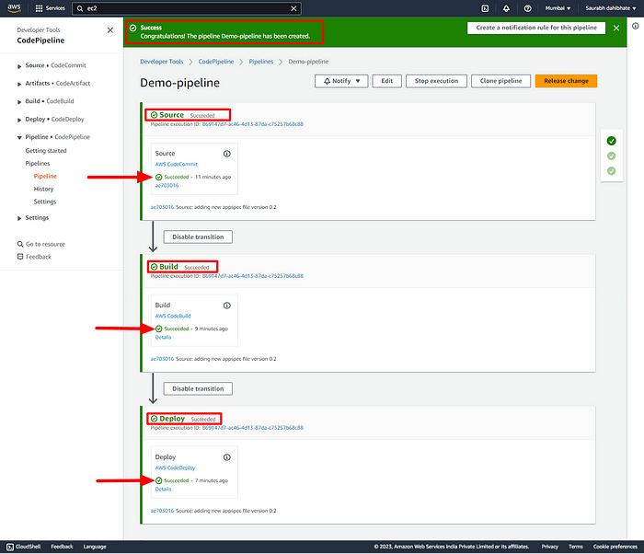

* Now, navigate to the public URL of the instance and check the Webpage.

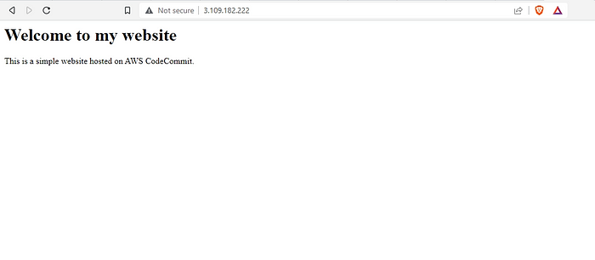

* We have successfully built the pipeline. Let’s witness the magic. Let’s modify our code and view the pipeline.
* I have changed my index.html file and committed it in the CodeCommit repository.

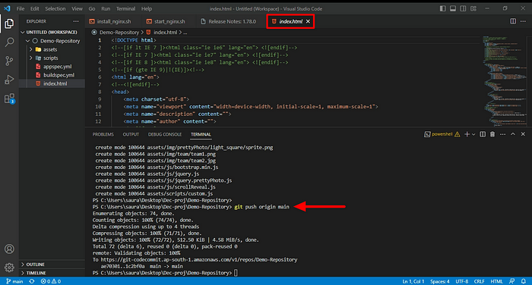

* The pipeline has automatically picked up the code from the repository, built nad deployed it in the server.

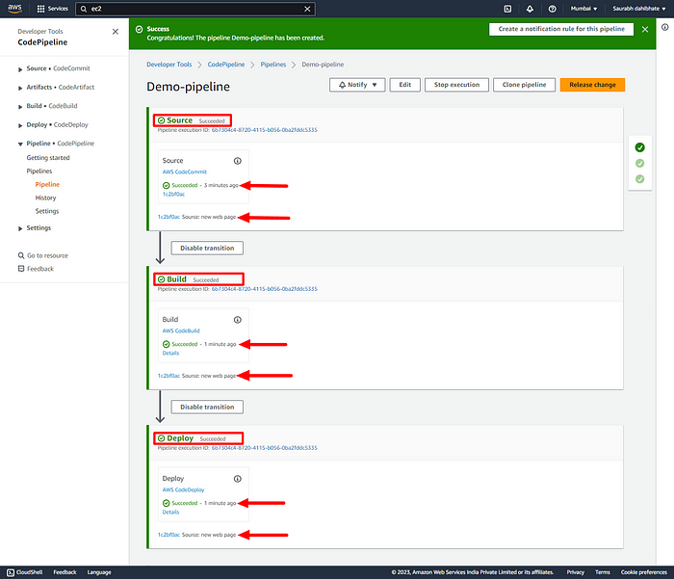

* Now check the public URL. Yes, I can see my new application with an eye-catching webpage.

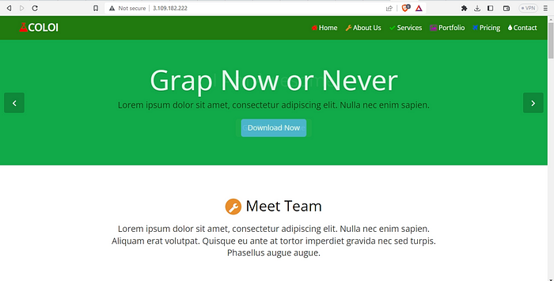

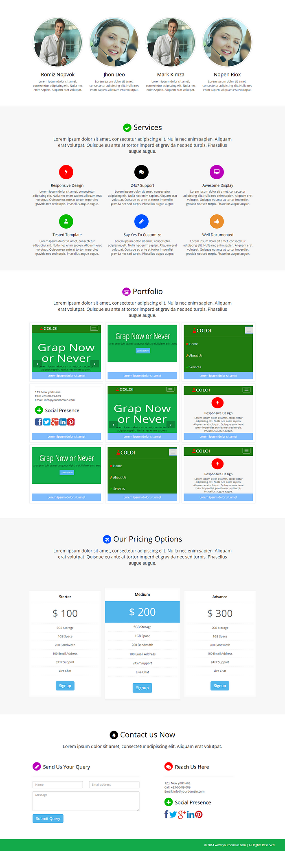

Have you enjoyed..??